# Website Themes

Themes change the appearance of the website, but not the content or functionality.

### Walk Through

When a user is logged in as a site admin they will see a link that takes them to the Theme Admin Page. Clicking the link takes them to a page that shows the current themes available for the site, and the theme that is currently applied. Clicking on a different theme highlights it. Clicking the apply button changes the current website theme and prompts the user that the action has taken place.

## Functional Requirements

**Website Theme Display**

When the website loads it uses a theme to render the appearance of the website. The theme consists of style sheets and images.

**Theme Admin Page Link**

Shows for site administrators

**Show the current and available themes**

The website will provide an admin page that shows all the installed themes for the website along with the currently installed theme.

**Apply a theme to the website**

The admin selects the theme they want to apply to the website and clicks the apply button.

**Download a theme**

The admin can also download the selected theme as a zip file.

**Upload a theme**

The admin can upload a zip file containing a theme to the website. Th e theme is extracted and becomes available for selection. If a theme already exists with that same name then a number is added to the end indicating a newer version of the theme.

**Delete a theme**

The admin can delete the selected theme after confirming the action.

## Future Enhancments

**Installing New Themes from a gallery**

The website will come with two or three pre-installed themes. A future enhancement will be to add the ability to browse all themes which will display a list of themes from the sbo website. The user could then install the theme and apply it to their website. Installing a theme will result in a new folder under the Themes directory. The admin page displays all the themes found in the folder.

### Currently Installed Theme

When the the website themes admin panel shows the currently installed theme is highlighted.

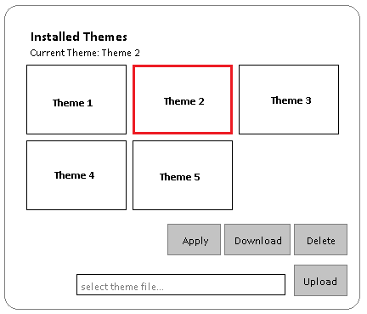

### Select new Theme

When the user clicks on a theme it becomed highlighted.

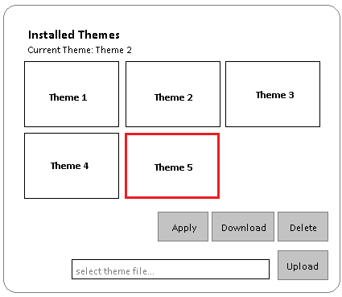

### Apply Theme to Website

When the user clicks the apply button the website changes appearance and a message displays letting the admin know that the update has taken effect.

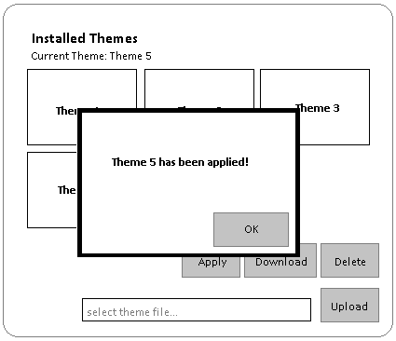

### Download a theme

When the user clicks the download button the theme downloads as a zip file.

### Upload a theme

The user selects a file using the file dialog, then clicks the upload button. The zip file is extracted to the themes folder. If a style.css file doesn’t exist the folder is deleted and an error is thrown saying that a style.css file must exist in order to be a valid theme. If it passes, then the new theme appears in the panel and is automatically selected.

### Delete a theme

The user clicks the delete button. If the theme is the current theme a message shows saying that the current theme can not be deleted. Otherwise a confirmation dialog appears. If the user clicks ok then the theme folder is deleted and removed from the panel.

## Software Design

### Data Context Diagram

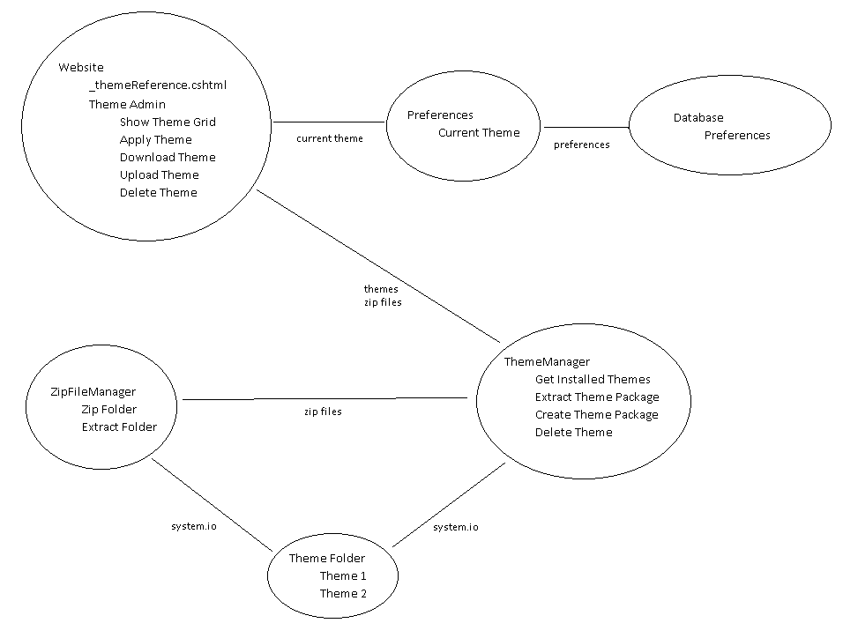

### Class Diagram

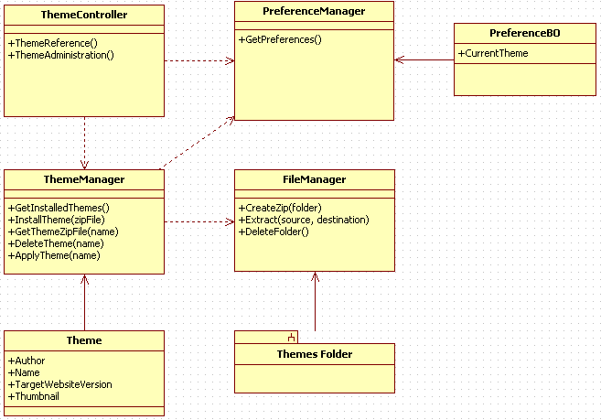

### Theme Controller

**ThemeReference**: uses the current theme from the preferences to render a link to the theme’s css file.

**ThemeAdministration**: uses the Theme Manager to display, select, and apply themes to the website. Also provides ability to upload, download, and delete themes using the Theme Manager.

### Preference Manager

**GetPreferences**: returns a business object providing the current theme for the website

### Theme Manager

**GetInstalledThemes**: returns a list of Theme objects for all the themes available for use on the website.

**InstallTheme**: extracts a theme folder from a zip file into the themes folder

**GetThemeZipFile**: creates a zip file from a theme folder and returns as a byte array for download

**DeleteTheme**: deletes a theme folder from the website

**ApplyTheme**: updates the current theme preference to applied theme

### File Manager

**CreateZip**:creates a zip file from a folder

**Extract**:extracts a zip file to a folder

**DeleteFolder**:deletes a folder